



**ACM STUDENT CHAPTER**

**Indira Gandhi Delhi Technical University for Women**

***अद्वय 2020***

*Certificate Of Participation*

This certificate is proudly presented to **Meghna Sharma** of university **USICT** in recognition of his/her participation in the event **Cybersecurity Session** held as part of **Advaya-2020**, from **12/04/2020** to **19/04/2020** .

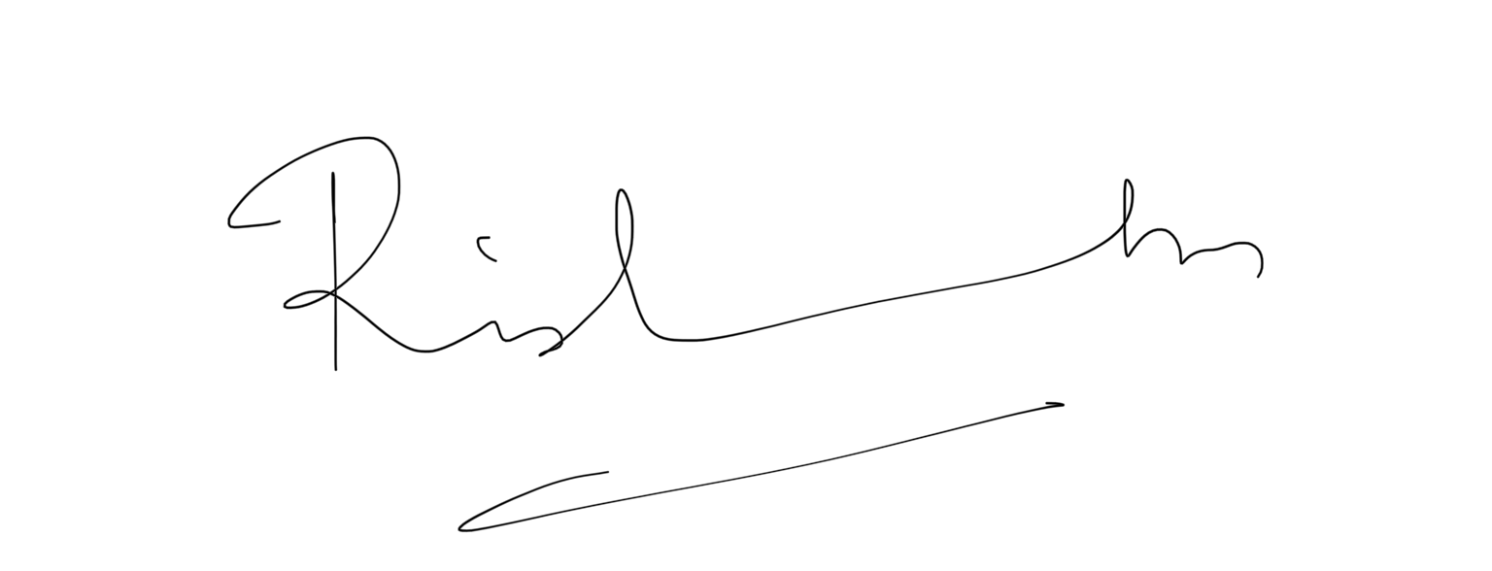

**Rishabh Kaushal**

**Faculty Advisor**

**ACM Student Chapter, IGDTUW**